Melis Family Minestrone: A Hearty and Healthy Recipe
This traditional Italian minestrone recipe, inspired by The Blue Zones Solution, combines wholesome, plant-based ingredients for a hearty, satisfying meal. Packed with vibrant vegetables, fiber-rich beans, and flavorful herbs, this dish reflects the Mediterranean lifestyle of the Melis family, emphasizing longevity and well-being.
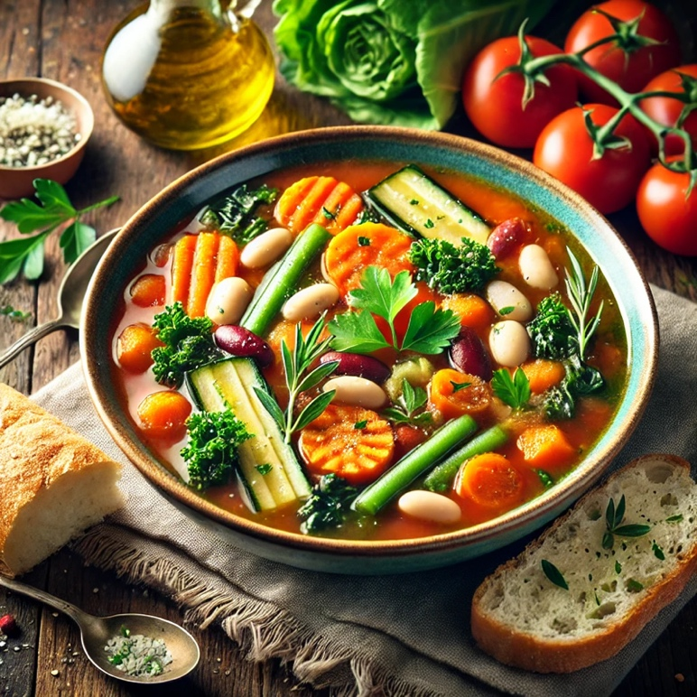
Ingredients (Serves 6-8)
Base Vegetables:
• 2 tbsp olive oil
• 1 medium onion, diced
• 2 medium carrots, diced
• 2 celery stalks, diced
• 3 garlic cloves, minced
Main Ingredients:
• 1 cup zucchini, diced
• 1 cup green beans, trimmed and cut into 1-inch pieces
• 1 cup peeled and diced potatoes (optional for added heartiness)
• 1 cup chopped tomatoes (fresh or canned)
• 4 cups vegetable broth
• 2 cups water
• 1 cup cooked white beans (cannellini or navy beans)
• 1 cup cooked kidney beans
• 1/2 cup uncooked pasta (elbow or small shells) or rice (optional)
• 2 cups chopped kale or spinach
Herbs and Seasoning:
• 1 tsp dried oregano
• 1 tsp dried basil
• 1/2 tsp dried thyme
• 1/2 tsp red pepper flakes (optional for spice)
• Salt and freshly ground black pepper, to taste
• 1 bay leaf
Toppings (Optional):
• Fresh parsley or basil, chopped
• Grated Parmesan cheese
• A drizzle of olive oil or balsamic vinegar
• Crusty bread for serving
Instructions
1. Sauté the Vegetables:
• Heat olive oil in a large pot over medium heat. Add the onion, carrots, celery, and garlic, and sauté for 5-7 minutes until the vegetables are softened and fragrant.
2. Build the Soup Base:
• Add the zucchini, green beans, potatoes, and tomatoes to the pot. Stir well to combine. Pour in the vegetable broth and water and bring the mixture to a gentle boil.
3. Season and Simmer:
• Add the oregano, basil, thyme, red pepper flakes (if using), bay leaf, and a pinch of salt and pepper. Reduce the heat to low, cover, and simmer for 20-25 minutes, allowing the flavors to meld and the vegetables to soften.
4. Add Beans and Pasta:
• Stir in the white beans and kidney beans. If using pasta or rice, add it at this stage and cook until tender, following package instructions (about 8-10 minutes).
5. Incorporate the Greens:
• Add the chopped kale or spinach to the pot and stir until wilted, about 2-3 minutes.
6. Adjust Seasoning:
• Taste the soup and adjust seasoning with additional salt and pepper, as needed.
7. Serve:
• Ladle the soup into bowls and garnish with fresh parsley or basil. For an extra layer of flavor, sprinkle with grated Parmesan cheese or drizzle with olive oil or balsamic vinegar. Serve with warm, crusty bread for a complete meal.
Tips:
• Make It Ahead: The flavors deepen when the soup rests, making it even better the next day. Store leftovers in an airtight container in the fridge for up to 5 days or freeze for longer storage.
• Customization: Feel free to use seasonal vegetables like squash, leeks, or cabbage to make it your own.
• Protein Boost: Add more beans or even a handful of cooked lentils for extra protein and fiber.

